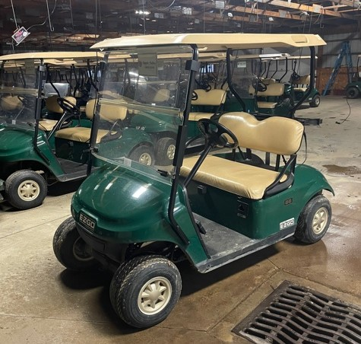
GOLF CARTS FOR SALE
2015 Electric TXT 48 Volt Fleet Cart.
Includes roof, windshield and charger.
All carts will run at least 18 holes on a charge.
All carts have been power washed after each round and the batteries have been cleaned and filled monthly since we bought them. These carts are in excellent used condition and have only been operated on the Apple Valley Golf Course.
$2500.00
Contact Mark at mark@applevalleygolfcourse.com

